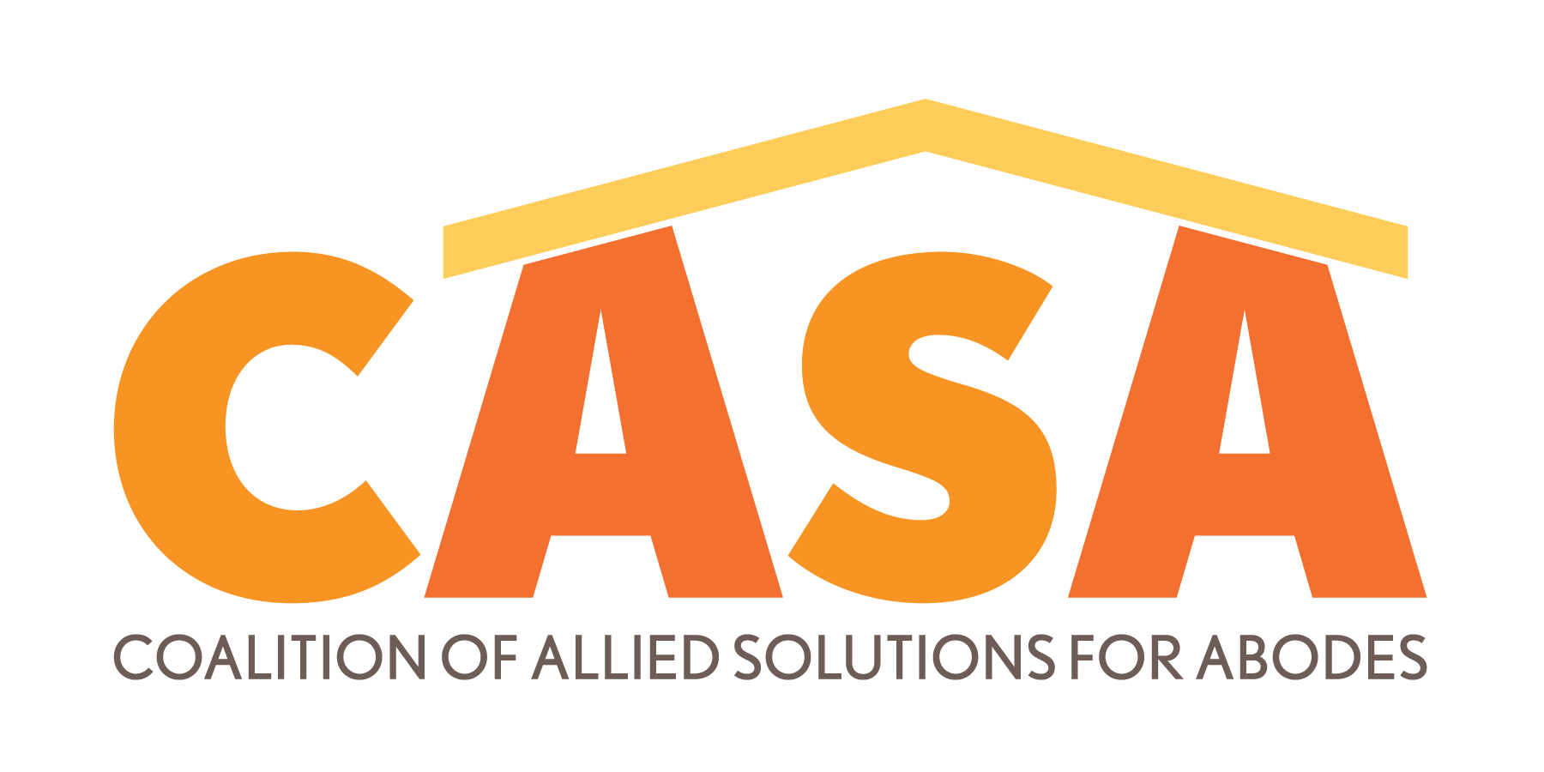

The current housing crisis is an issue created by inflation and lack of supply, and once in a generation job growth. While our community welcomes Netflix, Facebook, Amazon and the expansion of Intel, these new jobs, bring new people, who need new housing.

INFLATION IN HISTORY

The last time we saw inflation numbers like those we are seeing currently was from 1972 to 1975 when inflation increased 32%.

Today, the COVID-19 pandemic created supply chain issues and stimulus funds that have made new construction 30% more expensive.
MULTI-FAMILY HOUSING FACTS
- The average Albuquerque Metro apartment was built in 1972 and is 50 years old.
- 88% of apartment buildings in the metro are small
(20 units or less), which is 5,206 buildings out of the total 5,910 apartment buildings.
- Many of the apartment complex owners are your neighbors, not large out of state entities.

THE OUTCOMES OF RENT CONTROL:
- Will damage local landlords most, as most units are small and have small owners
(who own less than a dozen units)
- Will stop new development the moment we need it the most
- Will freeze owners’ income when their expenses are undergoing the worst inflation since the 1970s
- Will stop owners’ ability to renovate units or bring them into this century
- We will see more units move to owner occupancy
- Ripple effect will kill local construction jobs (our economy needs more)
- Will kill economic development – if there is no place to live, there is no place to add jobs

Unlike the last housing shortages, Albuquerque now has a perfect foundation to address this need:
- Fabulous IDO zoning that encourages redevelopment and new development
- An abundance of capital and financing (that will disappear if rent control is passed)
- A vibrant community of for-profit and non-profit developers

SOLUTIONS WILL ONLY COME FROM INCREASING SUPPLY – CONSIDER
- Speed up plan checks, building inspections and approvals
- Short term moratorium on the portion of GRT that goes to the State of NM (or all)
- Creating incentives for more developers to enter the market
- Creating incentives to offset the cost of moving from wood to steel construction and encouraging taller buildings in appropriate areas like downtown and uptown
- Working with local building codes and fire regulations to streamline the conversion
of office and retail into residential
- Incentivize CNM to create more 2-year certificate programs for labor workers

JOB/HOUSING NEEDS AS OF 10/6/2022

EBA for Albuquerque Area

F.A.A.(I).N.G. EFFECT | # of New Jobs | Basic | Basic Jobs | Non-Basic Jobs | Total Jobs

Facebook Construction (est.) | 500 | N |  | 500 | 500
Facebook Data Center Operations | 35 | Y | 35 |  | 35
Fidelity Investments | 240 | S | 106 | 134 | 240
Amazon Fulfillment Center – Project Chino | 1,500 | Y | 1,500 |  | 1,500
Amazon Sortation Center – Project Nico | 200 | Y | 200 |  | 200
Amazon Los Lunas – Project Charlie | 600 | Y | 600 |  | 600
Amazon Airport
Intel Construction | 1,000 | N |  | 1,000 | 1,000
Intel Expansion | 750 | Y | 750 |  | 750
NBC Universal Studios | 330 | Y | 330 |  | 330
Netflix Construction | 1,000 | N |  | 1,000 | 1,000
Netflix Production | 1,500 | Y | 1,500 |  | 1,500
Lance Industries | 70 | Y | 70 |  | 70
LQ Digital | 100 | Y | 100 |  | 100
Blue Halo (Additional Jobs Over 260) | 64 | Y | 64 |  | 64
MTX Group Inc. (Downtown) | 250 | Y | 250 |  | 250
Manna Capital LL | 950 | Y | 950 |  | 950
Curia | 674 | Y | 674 |  | 674
Vexus Fiber Optic | 200 | N |  | 200 | 200
KAFB Space Force | 100 | Y | 250 |  | 250
TOTAL | 10,063 |  | 7,379 | 2,834 | 10,213
EBM (Bernalillo County) | 7.84 | 1.00
Total New Jobs | 57,848 | 2,834 | 60,683
P/E Ratio = |  |  | 2.17
Total New People |  |  | 131,681
# Of persons per household |  |  | 2.52
Total New Households |  |  | 52,254
% That own |  |  | 35%
# Of new single-family residences needed |  |  | 33,965

% That rent | 35%
# Of new apartments needed at 100% occupancy | 18,289
Occupancy Rate at ideal market balance | 95%

# Of new apartments needed at 95% occupancy | 19,252
# Of new apartments built in 2020-2022 | 1,979
NEW Gap | 17,273

Total units ABQ/Rio Rancho | 91,148
Occupancy in 2019 – # of units occupied at 96% | 87,502
# Of vacant units = | 3,646

+New Gap+ occupied units – new occupied units | 104,775
% Occupancy | 115.0%

