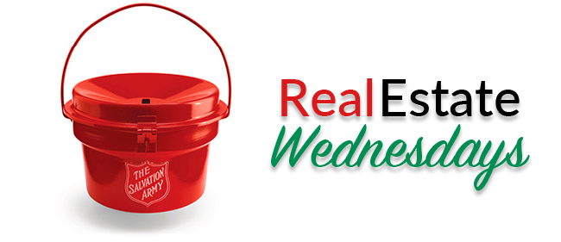

(We are/I am) involved in a wonderful partnership between the Greater Albuquerque Association of REALTORS® and The Salvation Army.

(We will/I will) be ringing a bell at (location) on Wednesday (date) from (start time) to (end time) and would love to see you there. Please drop by and help us do good.

(Personal Note Here)
Name
Company
Logo, etc.

